1. Write a paragraph proof.

Given: ∠T and ∠V are right angles.
Prove: ∆TUW∆VWU
​
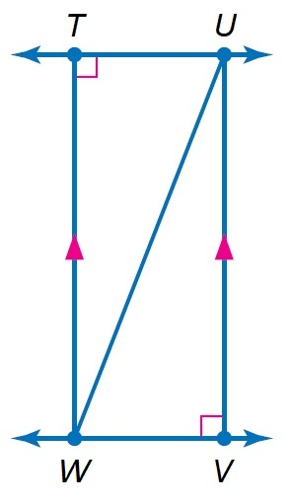
Solution
Given ∠T and ∠V are right angles.

TW is parallel to UV

To prove ⇒ ΔTUW ≅ ΔVWU. Proof ⇒ In ΔTUW and ΔVUW,

∠T ≅ ∠ V ≅ 90° ( which is already given)

Side UW ≅ UW ( Common in both the triangles )

TW is parallel to UV and UW is a transverse.

So ∠TWU ≅ ∠WUV [alternate interior angles]

Since Angle = Angle = side are equal

Therefore, ΔTUW ≅ ΔVWU

2. Sled kites rely on wind pressure to retain the shape of the sail. Each consists of a single square and two triangular pieces. Kyle has made a model of a Sled kite as shown below. Show that the angles and are congruent.
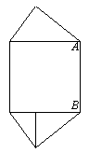(JUSTIFY)
Solution

The angles A and B are congruent. This is because each angle in square is a right angle.

3. A ray of light is reflected when it hits a mirror. The angle at which the light strikes the mirror is the angle of incidence, i. The angle at which the light is reflected is the angle of reflection, r. The angle of incidence and the angle of reflection are congruent. In the diagram below, if , what is the angle of reflection and
​
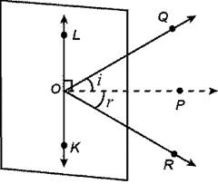(JUSTIFY)
Solution
The angle of reflection is equal to the angle of incidence.The angle of reflection is 62 degrees. The angle at ROK is 90-62=28 degrees.

4. Samantha has cut a pastry into four parts. Suppose and T is the midpoint of PR. Determine whether Justify your answer.
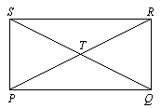

Solution
Since T is the midpoint of PR, As because alternate interior angles are congruent. Also, because vertical angles are congruent. So, by ASA(angle side angle).

If two angles and the included side of one triangle are congruent to two angles and the included side of another triangle, then the triangles are congruent.

5. A pathway divides a rectangular garden into two parts as shown. Find the measure of
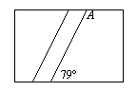
(JUSTIFY)
Solution

The angle is 180-79=101 degrees

6. Andy was playing a memory game with his sister. He turned over a tile to reveal a picture of the sun at the coordinates (5, 4). He looked under a tile that was 3 units to the left and 2 units down but revealed a picture of a tree. His sister knew that the other sun was 1 unit to the left and 1 unit up from the tree. What are the coordinates of the second sun?
(JUSTIFY)
Solution
The tree tiles coordinates are x = 5-3 = 2 and the y coordinate = 4 - 2 = 2
- that is (2, 2).
So the coordinates of the second sun are (2-1, 2 + 1)
= (1,3)

7. Carpenters use parallel wall studs to build support for walls. A carpenter has built two wall studs given by HG and CD in the figure below. Find the measure of so that the two wall studs are parallel.
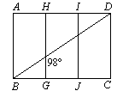
(JUSTIFY)
Solution
Since line HG and line IJ are parallel to each other. The angle at X is 98 degrees as well. Since angle at I is a right angle then angle ADB is 8 degrees.

Then angle is 90-8= 82 degrees

8. Richard ordered a coffee table that was a regular pentagon. Find the measure of an exterior angle of the table.
(JUSTIFY)

Solution
A pentagon has 5 sides.
360/5=72 degrees which is the size of the exterior angle.

9. Let be the median of LMBA. Find , , and .(JUSTIFY)
Use trapezoid ABCD to find each measure.
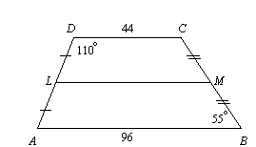
Solution
To get the median you need to sum the two bases to get
=44+96= 140
The median=140/2=70
The angle at A is adjacent to the angle at B. 180-55=125 degrees

The angle ALM is 110 degrees since its alternate to angle LDC.

10. In a museum, Nick is looking at a famous painting through a mirror at an angle of Find the angle the painting makes with the mirror. Also find and (JUSTIFY)
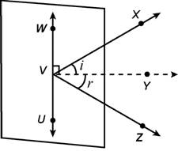

Solution
Calculate the angle of reflection by using the relation . The angle of reflection is equal to the angle of incidence. Hence its 58 degrees.
Also, i and are complementary i.e.

11. If a bike tire has 16 spokes spaced evenly apart, name its angles of rotation.
(JUSTIFY)
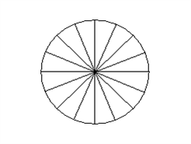
Solution
We are given that a bike has 16 spokes which are spaced evenly apart.
Since the total measure of angles for a circle is 360° and 16 spokes are places evenly, so each angle of rotation = 360/16 = 22.5°

12. Richard wants to buy a LCD flat panel monitor measuring 14 inches by 16 inches. What is the measure of the diagonal of the monitor?
(JUSTIFY)
Solution
The diagonals of the rectangle cut it into two congruent right-angled triangles. Therefore, to find the length of the diagonal of the monitor, use the Pythagoras Theorem. Since the base (b) is 16 inches and the perpendicular (p) is 14 inches, the distance of the hypotenuse (i.e. the diagonal, denoted by h) can be found by the following formula:

h^2 = b^2 + p^2
h^2 = 16^2 + 14^2

Simplifying gives:

h^2 = 452

Taking square root on both sides gives:

h = 21.26 inches (to the nearest 2 decimal places)

Therefore, the measure of the diagonal is 21.26 inches.

13. Samantha’s rectangular gift is 10 inches. by 12 inches and is framed with a ribbon. She wants to use the same length of ribbon to frame a circular clock. What is the maximum radius of the circular clock? Round to the nearest whole number.
(JUSTIFY)

Solution
The total length of the ribbon is its perimeter.
10+10+12+12=44
44=circumference
2*r*3.14=44
R=7 inches

14. Write a two-column proof.

Given:is the perpendicular bisector of
Prove:
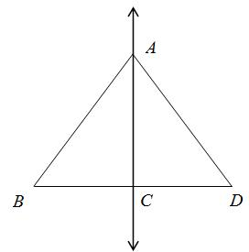

Solution
Angle ACB is a right angle definition of perpendicular. Angle ACD is a right angle definition of perpendicular
BC≅CD a bisector divides a segment into two congruent segments
AC≅AC reflexive property (any segment is congruent to itself)
Angle ACB≅ACD all right angles(90°) are congruent
Triangle ACB≅triangle ACD SAS (side-angle-side)
AngleB≅angleD corresponding parts of congruent triangles are congruent.
15. Write a flow proof.
Given:
Prove:
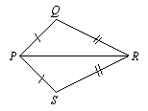
Solution
The triangle PDR is just but a reflection of triangle PSR. This simply means that the two of them are congruent and hence

16. Find the coordinates of the orthocenter of ΔYAB that has vertices at Y(3, –2), A(3, 5), and B(9, 1).(JUSTIFY)

Solution
A (3, -2) B(3, 5) C (9, 1)
Slope of AB = (5--2)/(3-3) = 7/0 = 0
y = mx + b (substitute m = 0, x = 3, y = -2)
-2 = 0(3) + b
b = -2
Equation of AB: y = 0x -2
Slope of BC = (3,5)/(9,1) = -4/6= -2/3
y = mx + b (substitute m = -2/3, x = 3, y = 5)
5= -2/3(3) + b
b = 7
Equation of BC: y = 3x +7
Step 2: Find the slope of the corresponding perpendicular lines
Slope of AB = 0
Slope of perpendicular line to AB: 0*m = 0 -> m = 0
Slope of BC = -2/3
Slope of perpendicular line to BC: 3*m = -1 -> m = 3/2
Step 3: Find the equation of the perpendicular lines
Slope of perpendicular line to AB: m = 0
We will use the coordinate of the opposite vertex (point C) to find the equation of the line.
y = mx + b (substitute m = 0, x = 9, y = 1)
5= 0(9) + b
b = 5
Equation of perpendicular line to AB: y = -2/3x + 7
Slope of perpendicular line to BC: m = 3/2
We will use the coordinate of the opposite vertex (point A) to find the equation of the line.
y = mx + b (substitute m = 3/2, x = 3, y = 5)
5= 3/2*(3) + b
b = 1/2
Equation of perpendicular line to AB: y = -2/3x + 7
Step 4: solve 2 perpendicular lines
equation 1: y = 0x + 2
equation 2: y = -2/3x + 7
Solving for x and y:
0x + 2 = -2/3x + 7
2/3x = -5
x = -15/3
y = 0(-5) + 2
y = 2
The coordinates are (-5, 2). This is the orthocenter.

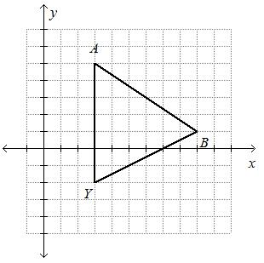

17. For isosceles trapezoid ABCD, find the length of the median and .(JUSTIFY)
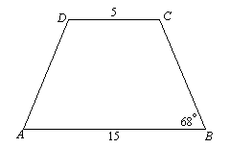
Solution
To get the length of the median you sum the two bases to get=20
Divide 20/2 to get=10
The length of the median is 10
The angle at A is 180-68=112 degrees

18. Write a two-column proof.
​
Given:
and are rt.
Prove: ∆ABC ∆ADC

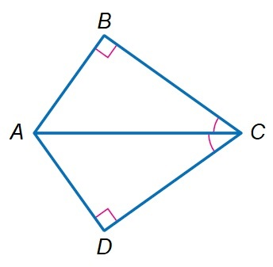
Solution
The triangle PDR is just but a reflection of triangle PSR. This simply means that the two of them are congruent and hence ∆ABC ∆ADC

19. A salesperson travels from city A to city B and then to city C. From city C, the salesperson travels directly back to city A as shown in the diagram below. Write the lengths of the legs of the trip in order from least to greatest.(JUSTIFY)
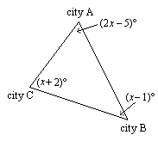
Solution
City C to city A, city A to city B, City B to city C
If one angle of a triangle has a greater measure than another angle, then the side opposite the greater angle is longer than the side opposite the lesser angle.

20. A construction manager moved a shed to the back corner of a lot. Because there were so many trees in the way, the construction manager had to move it 6 units up, 2 units to the left, 2 units down, and 3 units to the left. The vertices are now (5, 5), (0, 5), (5, 3), and (0, 3). What were the original vertices of the shed?
(JUSTIFY)
Solution
The shed was moved 4 units up and 5 units left. Therefore to get the original position we have to do the opposite. Move the shed 4 units down and 5 units right.
We therefore get (-9,10), (-4,10), (-9,8), (-4,8).
This the original position of the shed.

